Video Keyframe Extraction and Embedding System Documentation

1. Overview
This project implements a video understanding pipeline that extracts representative frames (keyframes) from a video and converts them into semantic embeddings using the CLIP model.
The system reduces redundant frames using histogram-based change detection and grid-based clustering, then encodes keyframes using CLIP (Contrastive Language–Image Pretraining) to produce vector embeddings suitable for:
- Video search
- Video captioning
- Video similarity retrieval
- Event segmentation
- Video summarization
The project contains three major components:
- Histogram-based frame filtering
- Grid-based keyframe extraction
- CLIP embedding generation and fidelity evaluation

2. System Architecture

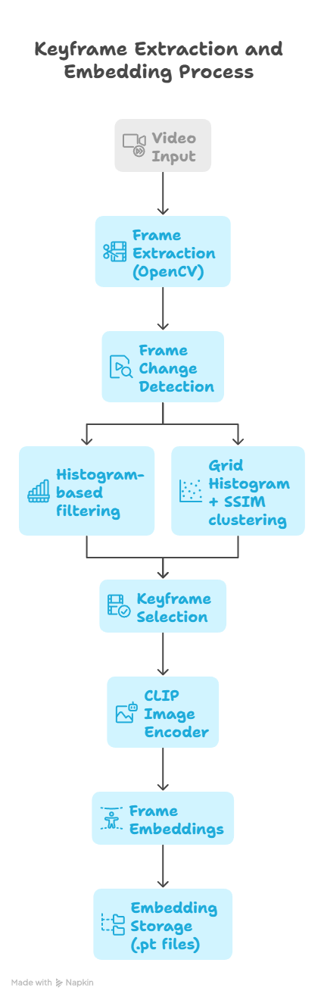

3. Technologies Used
Technology | Purpose
OpenCV | Video processing and frame extraction
PyTorch | Deep learning tensor operations
CLIP (ViT-B/32) | Image embedding generation
NumPy | Histogram feature operations
scikit-image | Structural Similarity (SSIM) computation
PIL | Image conversion for CLIP preprocessing

4. Image Embedding Module
File: ImageEmbedding.py

Purpose
This module converts an image into a semantic vector embedding using the CLIP model.
CLIP embeddings represent the semantic meaning of the image, allowing comparison between images and text.

Function

process_image(image, device, model, preprocess)

Description
Encodes a preprocessed image into a normalized CLIP embedding vector.

Parameters
Parameter | Type | Description
image | Tensor | Preprocessed image tensor
device | String | CPU or CUDA device
model | CLIP Model | Preloaded CLIP model
preprocess | Function | CLIP preprocessing pipeline

Process
- Image is passed into the CLIP encoder.
- A feature vector is generated.
- The vector is normalized using L2 normalization.

Output
Returns a normalized embedding vector.

Code Logic
image_embedding = model.encode_image(image)
image_embedding = image_embedding / image_embedding.norm(dim=-1, keepdim=True)

Normalization ensures that cosine similarity can be used reliably.

5. Histogram Based Frame Selection
File: histogram.py

Purpose
This module reduces the number of frames processed by detecting visual changes between consecutive frames using histograms.
This avoids encoding redundant frames.

Algorithm
- Extract frame from video
- Compute grayscale histogram
- Compare histogram with previous frame
- If change exceeds threshold → keep frame
- Convert frame to embedding

Function

video_to_frames(video_path, threshold=0.5)

Parameters
Parameter | Description
video_path | Path to input video
threshold | Histogram difference threshold

Steps
- Open video using OpenCV
- Extract frames sequentially
- Compute histogram using:
cv2.calcHist([frame], [0], None, [256], [0,256])

- Normalize histogram
cv2.normalize(hist, hist)

- Compare histograms using Bhattacharyya distance
cv2.compareHist(prev_hist, hist, cv2.HISTCMP_BHATTACHARYYA)

- If difference exceeds the threshold → frame is processed.
- Frame is converted to CLIP embedding.

Output
Returns:
features → tensor of frame embeddings

6. Grid Histogram Keyframe Extraction
File: GridApproach.py

Purpose
This module improves keyframe detection by analyzing local visual changes instead of global changes.
Each frame is divided into 3×3 spatial grids, and color histograms are computed for each block.
This improves detection of:
- Scene transitions
- Object movements
- Local visual changes

Step 1 — Frame Extraction

extract_frames(video_path)
Extracts frames and grayscale versions.
Frames are resized to:
640 × 360

Grayscale frames are resized to:
160 × 90

This speeds up SSIM computation.

Step 2 — Grid Histogram Feature

grid_histogram(frame)
Each frame is divided into:
3 × 3 grid blocks

For each block:
RGB histogram = 6 × 6 × 6 bins

Histogram dimension per block:
6 × 6 × 6 = 216

Total feature size:
9 × 216 = 1944 features

Step 3 — Histogram Distance

histogram_distance(h1, h2)
Computes difference between histograms using:
Euclidean distance

Step 4 — Keyframe Extraction

extract_keyframes(video_path)
Keyframes are detected using two metrics:
Metric | Purpose
Histogram distance | Detect visual change
SSIM | Verify structural difference

Keyframe Selection Logic
- Compute histogram difference between frames
- If difference exceeds threshold:
hist_diff > hist_threshold

- Compute structural similarity:
SSIM(frame_i , frame_j)

- If similarity is low → new scene detected
similarity < ssim_threshold

Frames are grouped into clusters.

Representative Frame Selection
For each cluster:
middle frame = keyframe

This ensures the keyframe best represents the scene.

7. Keyframe Embedding Generation
Function:
keyframes_to_embeddings()

Steps:
- Convert BGR → RGB
- Apply CLIP preprocessing
- Encode image using CLIP
- Normalize embedding
- Concatenate embeddings
Output:
tensor of keyframe embeddings

8. Fidelity Evaluation System
File: fidelity_finder.py

Purpose
Measures how well keyframes represent the entire video.

Step 1 — Generate Embeddings
Two sets of embeddings are created:
Type | Description
all_embeddings | embeddings for every frame
key_embeddings | embeddings for keyframes

Step 2 — Similarity Calculation
For each frame embedding:
cosine_similarity(frame_embedding , keyframe_embeddings)

The best similarity score is selected.
best = max(similarity)

Step 3 — Fidelity Score
Fidelity is computed as the average similarity.
fidelity = average(best similarities)

Interpretation
Fidelity Score | Meaning
~1.0 | keyframes perfectly represent video
~0.9 | very good representation
~0.7 | moderate representation
<0.5 | poor keyframe selection

9. Embedding Storage
Embeddings are stored using PyTorch:
torch.save(embedding, "video1001.pt")

Advantages:
- Fast loading
- Efficient storage
- Compatible with deep learning pipelines
These embeddings can be used for:
- Video retrieval
- Similarity search
- Caption generation
- Event detection

10. Performance Optimization
The system reduces computation through:

Frame Reduction
Histogram filtering removes redundant frames.

Grid Histogram
Captures spatial changes.

SSIM Verification
Avoids false scene changes.

CLIP Embeddings
Provides semantic representation.

11. Output Example
For each video:
video1001.mp4

Output:
video1001.pt

Where:
embedding tensor shape:
[number_of_keyframes , 512]

